This process shows you how to transfer multiple students from one course section to another. A schedule must be finalized before it can be transferred.
Step 1: Go to Home » SIS » Scheduling » Bulk Course Section Management
This utility will not allow you to transfer course groups.

Step 2: Enter the course and section. Click the View button. If you not sure what course it is, you can use the button to search through the courses.
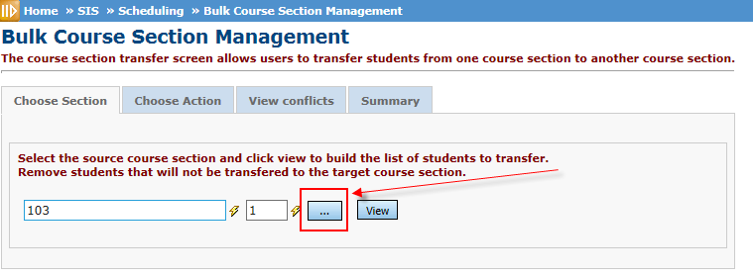

Step 3: The current list of students who are in that class will appear. Red “X” the students you WANT TO STAY IN THIS CLASS. This will remove them from this process leaving you with a list of students you are going to transfer to a different course/section. Once you remove the students you want to keep in the course, click Next.

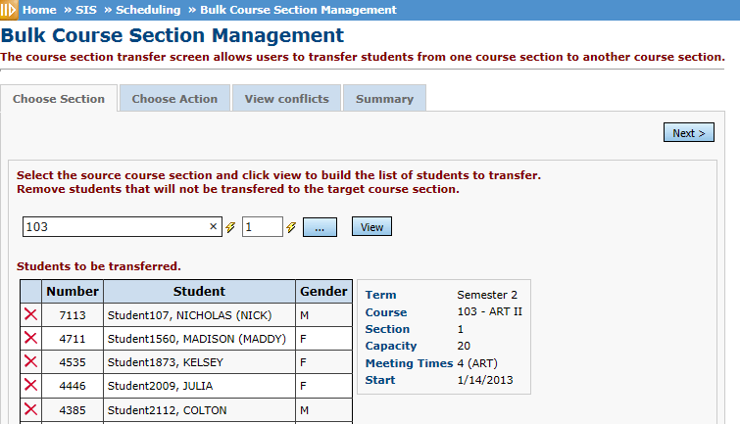

Step 4: Click on the Transfer Radio Button Section. Enter the Course/Section you want to transfer the list of students into, then place the stop date, which is the last date they attended the original class. Then click the Next button.
If the students have Marks that need to carry over to the new course, both courses have to have the same course term and course type. Also, don’t use the Remove option under Transfer Section or the marks will not transfer. If there are no marks and the student never attended the other course, then you could use the Remove Section, instead of the Transfer Section (unless it is a Career Tech course. Per ODE requirement, after EMIS reporting begins CTE students can’t be removed, they must be dropped).
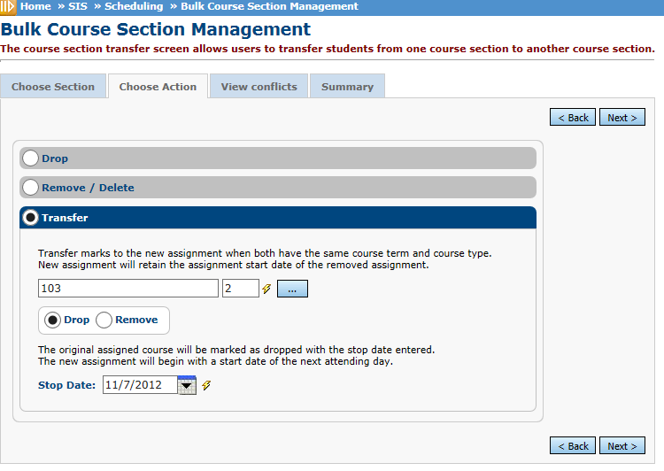

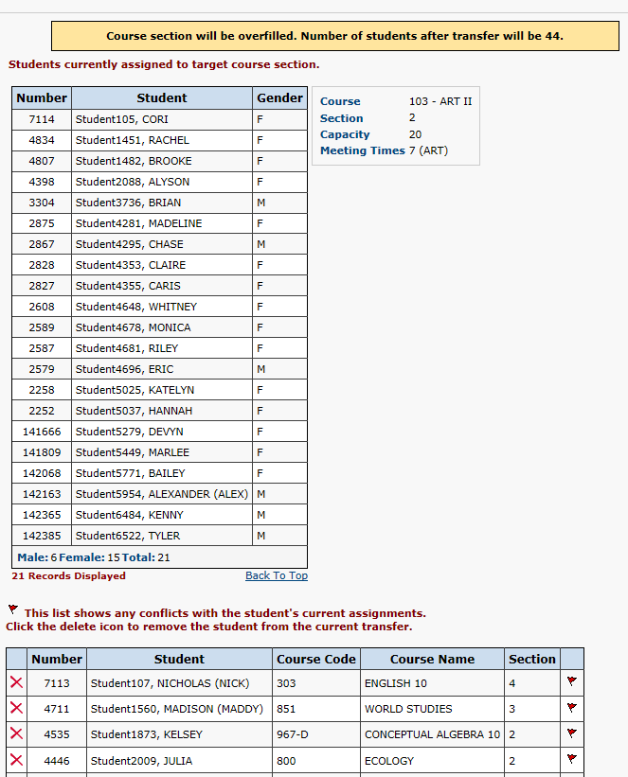
Step 5: The View Conflict Screen will display current students assigned to the course section you chose in step 4 and will list any potential conflicts you may have with the students you want to transfer. Some students may already have a class scheduled in the period you chose for the new section. You have the option to remove those students and do another transfer with those students after this transfer. Once you determine how to correct the conflicts, click the Next button.

Step 6: The Summary tab will list the students you want to move. Press Submit to transfer.
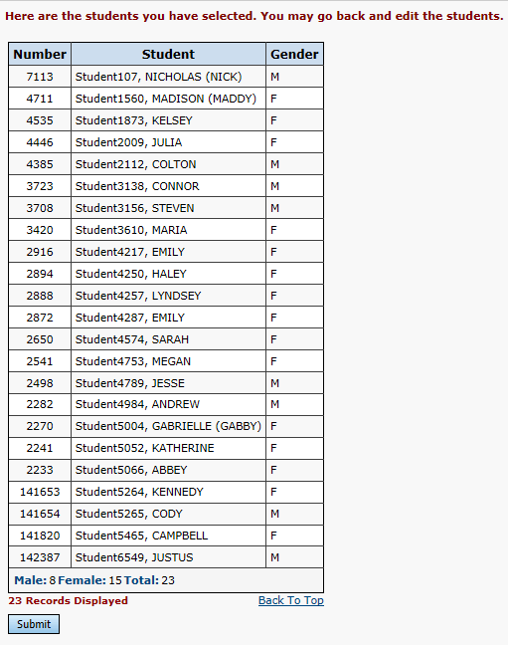

Step 7: Once transfer is complete, look at the schedule for a couple of the students to verify the transfer.

